Getting Started Guide & FAQs of Pyro S

Getting Started

1 Installation
- The transmitter has a red label and the receiver has a blue label.
- Connect the transmitter to the video resource through an HDMI cable.
- Power the device with a DC adaptor, NPF-battery.
- Install the Receiver 1.7m above the ground.
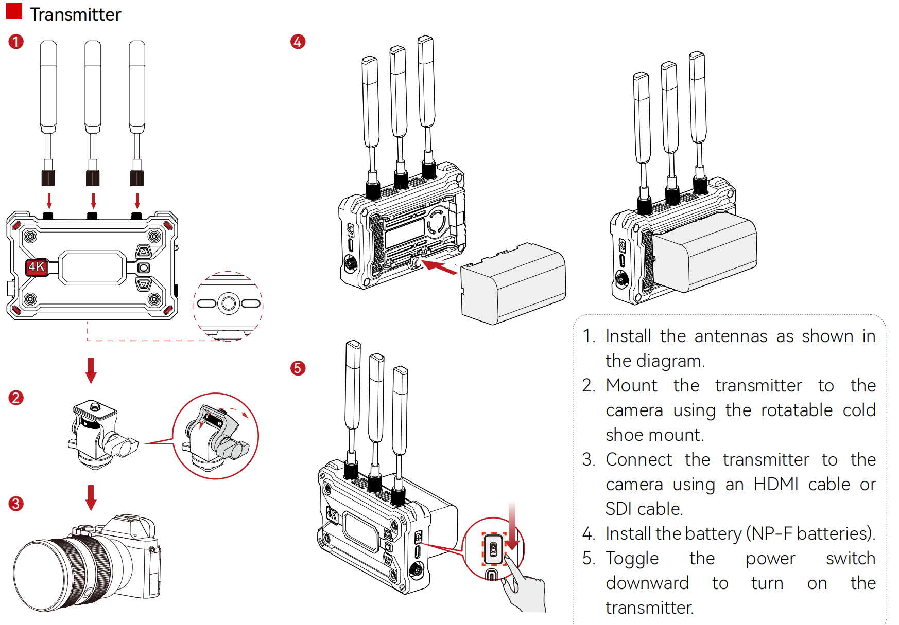

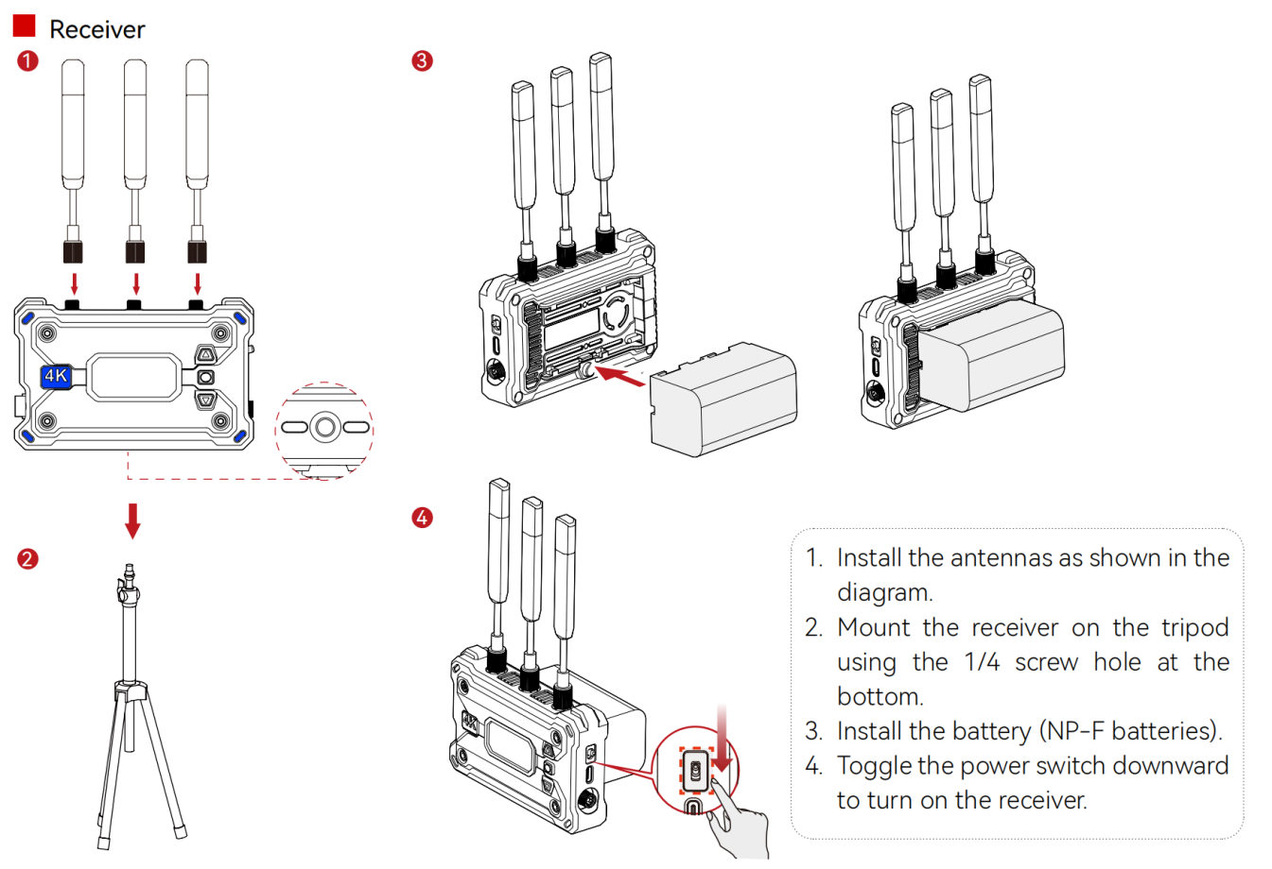

2 Multi Sets Installation
- Up to 4 sets of Pyro S at the same location （Up to 2 sets in Broadcast Mode）.
- Choose different frequency channels, and the channels chosen should be at least 2 channels apart.
- Place the receivers at least 0.5m away from each other.
- Place all receivers 1.7m above the ground.
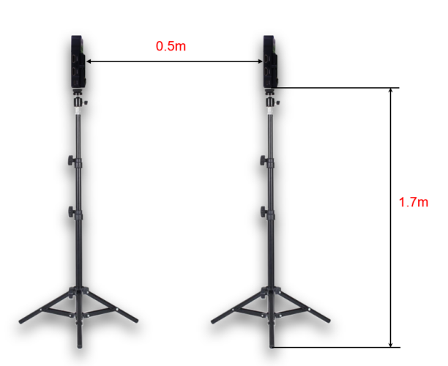

3 Channel Scanning
Only the receiver can perform the channel scanning function. Long press the thumbwheel switch for 3 seconds to enter the menu. Scroll the switch up and down to select the function and press the switch to confirm.
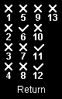Please choose Scan to start channel scanning.

4 Scene Mode Selection
Only the transmitter can select scene modes. Different scene modes are designed for different application scenarios.
- HD Mode: Support up to 12 Mbps high bit rate, excellent video quality, ideal for Microfilm and advertising shooting
- Smooth Mode: Adjust video quality to maintain low latency when interference occurs, suitable for live shooting

5 Fan Mode Selection
Only the transmitter support adjusting the fan speed.
- Auto: The device automatically adjusts the speed of the fan according to its temperature (noise up to 55dB).
- Low: The fan speed is reduced to a minimum (45dB), and the temperature of the device will be slightly higher.

6 Monitor By HollyView APP
Download the HollyView App from your mobile store and check if your device supports 5G Wi-Fi.
Note: Android devices can only connect to channels 1, 2, 11, 12, and 13, while iPhone devices can connect to all channels.
Steps for connecting the HollyView App:
- Find the WIFI PASSWORD on the menu of the transmitter.
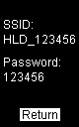
- Enter the Wi-Fi password and connect to the "HLD_XXXXXXX" network.
- Open the HollyView App and Click " Connect " to get the video feed.
Notes:
- It is advised to turn off the "Wi-Fi Assist" function in the "Cellular" settings for the first time.
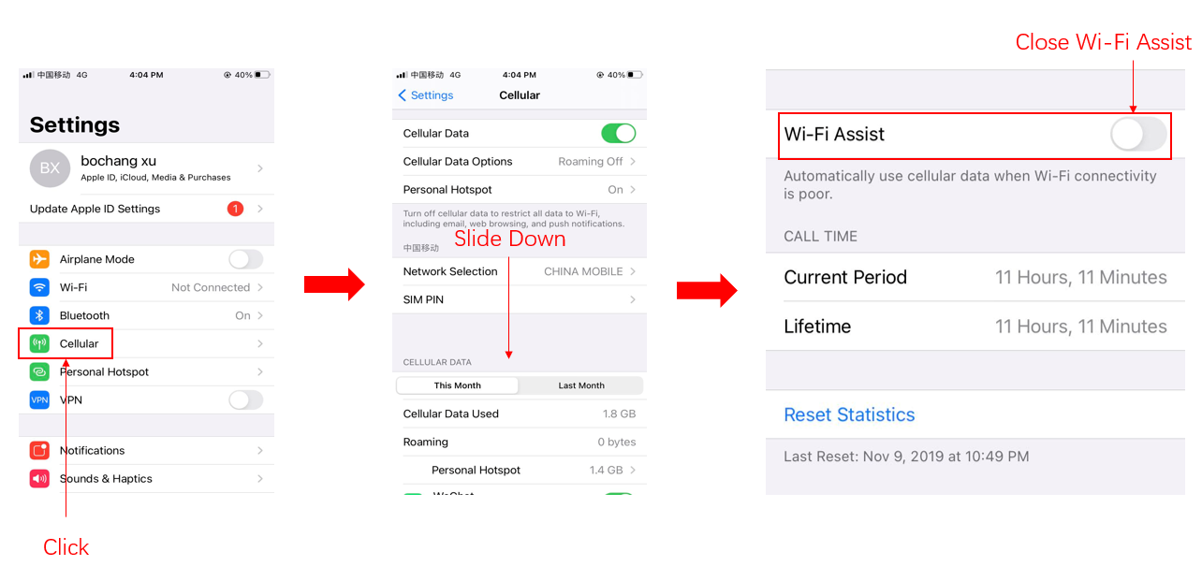
- Turn off the "Auto-join" function in the "Wi-Fi" settings.
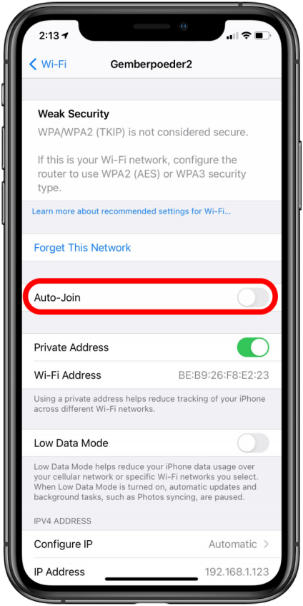
- Permit the HollyView to access your location.

FAQ

Pre-sales FAQ

1 Parameters:
 | Transmitter (TX) | Receiver (RX)
Ports | • DC Input: 2.0mm Core Socket  • HDMI Input: HDM1 1.4b  • SDI Input: 3G-SDI  • USB-C: USB 2.0 OTG  • Antenna: SMA Male | • DC Input: 2.0mm Core Socket  • HDMI Output: HDM1 1.4b  • SDI Output: 3G-SDI  • USB-C: USB 2.0 OTG  • Antenna: SMA Male
Power supply voltage | • Battery Voltage Range: 6.8 - 8.4V  • DC Voltage Range: 6 - 16V | • Battery Voltage Range: 6.8 - 8.4V  • DC Voltage Range: 6 - 16V
Power | <11W | <8W
Net weight | 207g | 207g
Dimension | L × W × H: 112 × 71.2 × 34.1mm
Video IN/OUT format | HDMI:  720p50/59.94/60  1080i50/59.94/60  1080p23.98/24/25/29.97/30  1080p50/59.94/60  4K30/25/24/29.97/23.98  SDI:  720p50/59.94/60  1080i50/59.94/60  1080p23.98/24/25/29.97/30  1080psf23.98/24/25/29.97/30  1080p50/59.94/60 | HDMI：  720p50/59.94/60  1080i50/59.94/60  1080p23.98/24/25/29.97/30  1080p50/59.94/60  4K30/25/24/29.97/23.98  SDI：  720p50/59.94/60  1080i50/59.94/60  1080p23.98/24/25/29.97/30  1080p50/59.94/60  UVC：  1080P30
Frequency | 5 GHz Frequency Band  5.150 - 5.250 GHz  5.250 - 5.350 GHz  5.470 - 5.725 GHz  5.725 - 5.850 GHz  2.4 GHz Frequency Band  2.412 - 2.484 GHz
Modulation method | QAM | QAM
Tranmission strength | Max. 30dBm | /
Receiving strength | / | -82dBm
Latency | < 0.5s
Bandwidth | 20MHz  40MHz（Broadcast）

2 Power supply

2.1 What kinds of batteries are supported for Pyro H?
Use the SONY NP-F series battery to power the device such as F970, F750 and F550. You can also use the V-mount battery when you have a D-Tap to DC cable.

2.2 Does it support the use of a USB-C charger to power the device?
Not Support

2.3 Does it support the use of a DC adapter to power the device?
The device supports power supply through the DC adapter with a voltage input from 6-16V.

2.4 Why does the device show battery voltage instead of battery percentage?
Due to the wide variety of brands and models of NP-F batteries on the market, each with different capacities and discharge curves, external devices are unable to accurately detect the remaining battery capacity. Voltage, on the other hand, provides a more accurate indicator of the remaining battery life.

3 What is the difference between the Mars Series with Pyro Series

3.1 The working band is different.
The Mars series only supports the 5G band, while the Pyro series offers an additional option of 2.4G. This means that in non-broadcast mode, the 2.4G can free up some 5G resources, making 5G transmission more stable. In broadcast mode, the 2.4G can improve transmission stability when compared to traditional broadcast which not support supplementary packet transmission.

3.2 The quantities of receivers can be connected with one Transmitter.
Mars series could support up to 2 receivers, but Pyro series support up to 4 receivers in broadcast mode.

3.3 The pairing method is different
Compared to the Mars series, the Pyro series can easily pair TX/RX by putting them in the same group for automatic pairing.

3.4 Frozen frame function
When activated, this function causes the RX to output the last frame continuously instead of displaying the Hollyland logo.

3.5 Auto channel selection mode
Support auto channel selecion(there will be a lost 1-second signal)

3.6 Streaming function
The usb-c support insert networks card then stream via our latest hollyview app.
- You need prepare a networks card(We recommend usb-A card)
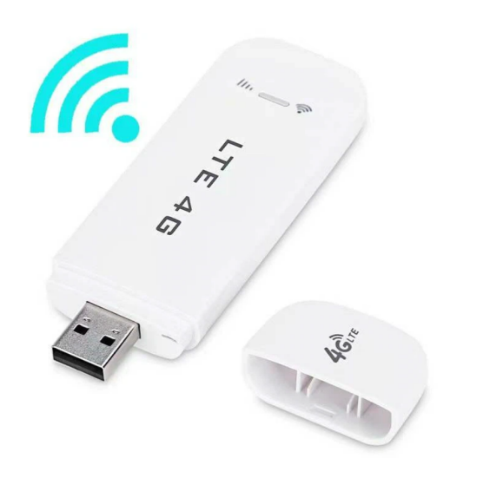
- Insert the card via usb-c OTG accessories with our device.
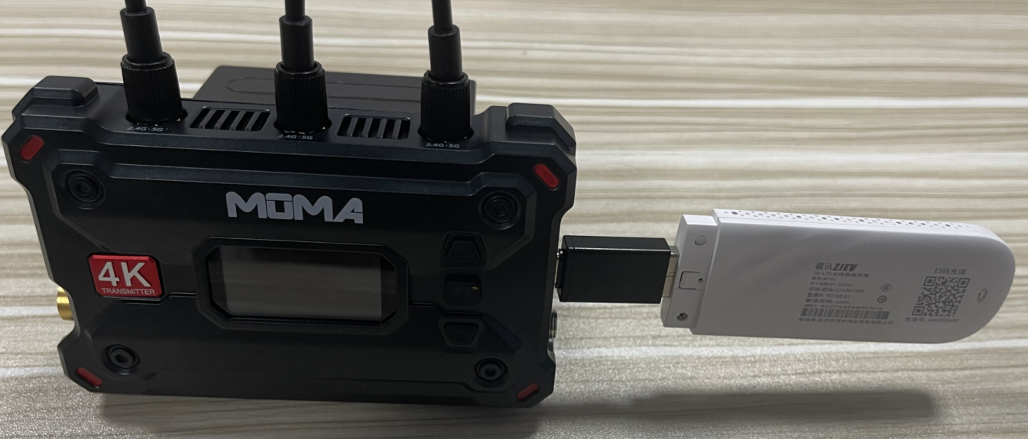
- Connect with our latest Hollyvie App and input the streaming address and key then start streaming.

Operations FAQ

1 Interference

1.1 The walkie-talkie signal interference.
The casing of the device is made of metal, so the internal circuitry is impervious to external wireless interference. In cases where walkie-talkies with higher power output may potentially cause interference, especially when using HDMI/SDI cables with poor shielding, it could result in a black screen. In such situations, we recommend replacing the cables with ones that have better shielding. Keeping a safe distance of at least 1 meter between the walkie-talkies and the cables is advisable. Opting for a wireless communication system with lower transmission power is another secure solution.

2 Abnormal issues

2.1 How to solve problems like video freezing, blurriness and mosaic?
- Channel scanning for free channel selection or Active the auto channel selection
- Correct installation.
- Ensure that the power supply is stable.

2.2 How to solve the "No Video" issue from the transmitter?
- Examine the HDMI cable for proper functionality: connect the camera directly to a monitor to verify if the video output is normal.
- Use an HDMI output from a laptop to connect to the video transmitter. Observe if the transmitter screen displays the video format correctly.

2.3 The camera's screen turns black when starts recording?
With any Micro single/SLR camera, only one of the HDMI video output and the camera's screen display can be enabled when you are recording 4K video because of the limitation of the camera itself. So you can try to set the shooting format as 1080. Photography cameras do not have this limitation.
If you want to use a Micro single/SLR camera to record 4k video and monitor the shooting simultaneously, you can connect Camera->ATOMOS Recorder->Transmitter

2.4 How to solve the issue of SONY Micro single camera's screen turning black?
Please configure the camera HDMI settings as below:
- Change HDMI output format to 1080p/i (Not recording format)
- Set HDMI Information Display to OFF
- Set HDMI Control to OFF

2.5 The screen turns green when connected with ATEM mini?
The HDMI IN 1 port of the ATEM mini switcher only supports RGB mode, while HDMI IN 2, 3, and 4 support YUV mode. Our device supports YUV mode.

2.6 Why does screen freezing or mosaic happen on the HollyView APP?
Please keep the mobile phone at least 2m away from the transmitter.

3 Connection

3.1 The transmitter works fine but the receiver's connection is lost?
- Make sure to use a DC adapter or NP-F battery for power supply, and the battery should be fully charged.
- Select "CHANNEL SCAN" to choose a clean channel to avoid frequency interference.
- Keep the transmitter at least 1m away from the receiver, and then do the group pairing.

3.2 How many receivers can connect with the same transmitter simultaneously?
One transmitter can connect with 4 receivers at the same time when you turn on the broadcast mode.

3.3 How to pair a new receiver with the current system?
Set TX/RX in the same group, then they will start pairing automatically.
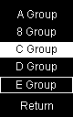

3.4 How many smartphones/tablets can connect to the transmitter simultaneously?
Up to 2 smartphones/tablets can connect to the transmitter, but not support in Broadcast Mode.

4 Others

4.1 How to add LUTs to the HollyView App?
Note: The LUT file should be .Cube format and the size of the file is 17 or 33.
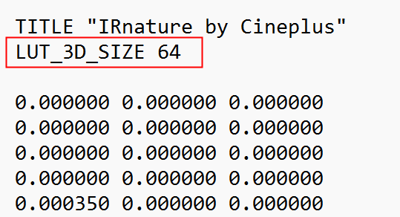

iOS Devices:
Method 01: Import through Online Chat or Airdrop APP
- Download the LUTs file to your computer.
- Send the LUTs file to the iOS devices via any Online Chat app (like WhatsApp) or Airdrop APP.
- Select that file and choose HollyView App to open the file.
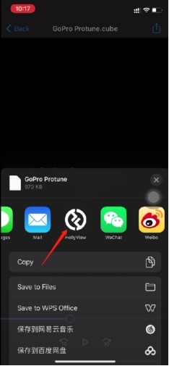
Method 02: Copy the file to Hollyview 【3DLUT】 file path
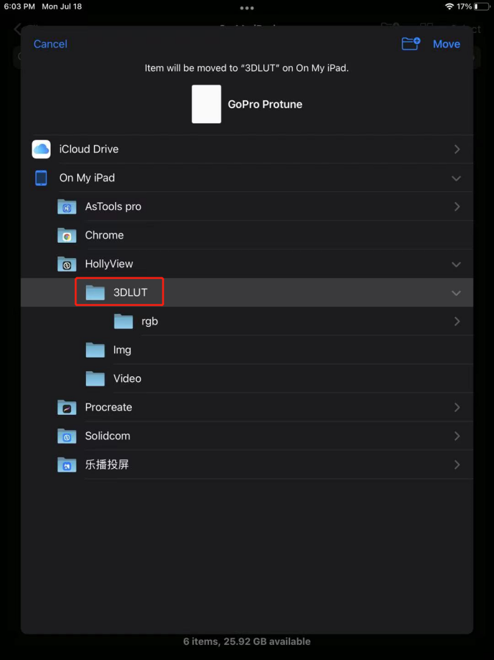

Android Devices:
- Download the LUTs file to the Android Devices.
- Open the HollyView App and choose the LUTs option. Select "Add a new file."
- Choose the downloaded LUT file.

4.2 How to test the latency of the device correctly?
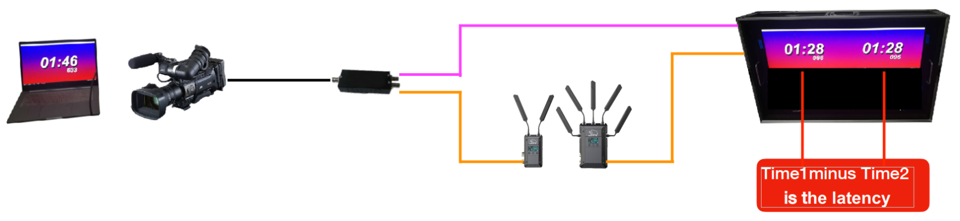

4.3 The audio and video are out of sync when video is directly transmitted to the control room, but audio is transmitted to the control room through an audio mixer.
- The latency of the Mars Pyro H is around 60 ms.
- If the video is sent through the Pyro H, and the audio is sent through another path, then there is a latency of 60ms.
Solutions:
- Both video and audio are transmitted through the Pyro H. For example, mount the microphone and the Pyro H on the camera together, and then the audio and video will be sent simultaneously.
- Apply a 60 ms delay to the audio on the devices such as the mixer or the OBS software.

Troubleshooting

1 Function failure

1.1 Factory reset
Reset the device by long pressing the thumbwheel button to enter the menu interface, and select System > Reset.

1.2 Firmware upgrade
Note: TBD.
Download path:
TBD

Follow the steps below to upgrade:
1. Prepare a USB disk(16/32G), then format it to the FAT32 file system.
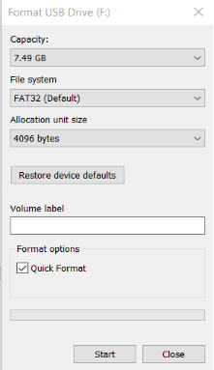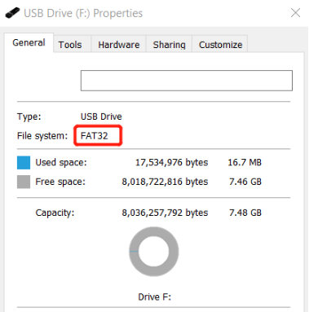

2. Download the files needed to upgrade to the root directory of the USB disk.
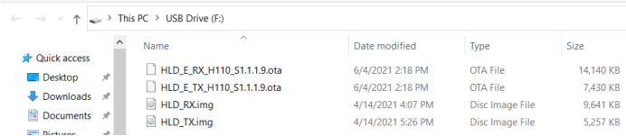

3. Connect the USB disk to the device, and the upgrading process will automatically begin after the restart of the device

2 Others

2.1 Why I can turn on the device with a DC adapter but not an NP-F battery?
Please go to the local service center for repair services.

2.2 Device's casing and structure damage
If you find that the casing, cold shoe, battery connector, DC adapter port, or external antenna connector is damaged, please go to the local service center for repair services.

