Getting Started Guide & FAQs of Solidcom C1 Pro Roaming Hub
Title | Getting Started Guide & FAQs of Solidcom C1 Pro Roaming Hub | Document ID | AS-240808003
Author | Aaron | Department | Sales & Engineering Department
Version | V1.0 | Update Date | 2024–08–29
Reviewer | @王国琛(王国琛 Zachary) | Review Date
Security Level |  | Release Date
Solidcom C1 Pro Roaming Hub官网发布资料
内容更新时间 | 更新内容 | 文档更新人 | 官网更新人 | 官网更新状态 | 官网更新时间
2024-08-29 | 初步分类 | Aaron

Getting Started Guide

Hub Installation
a. The distance between two hubs is at least 1.5 meters when multiple Solidcom C1 Pro Roaming Hub systems are cascaded.
b. You are advised to install the hub at a place higher than 1.7 meters in an open space. A confined environment may affect the wireless signal quality and reduce the transmission range.
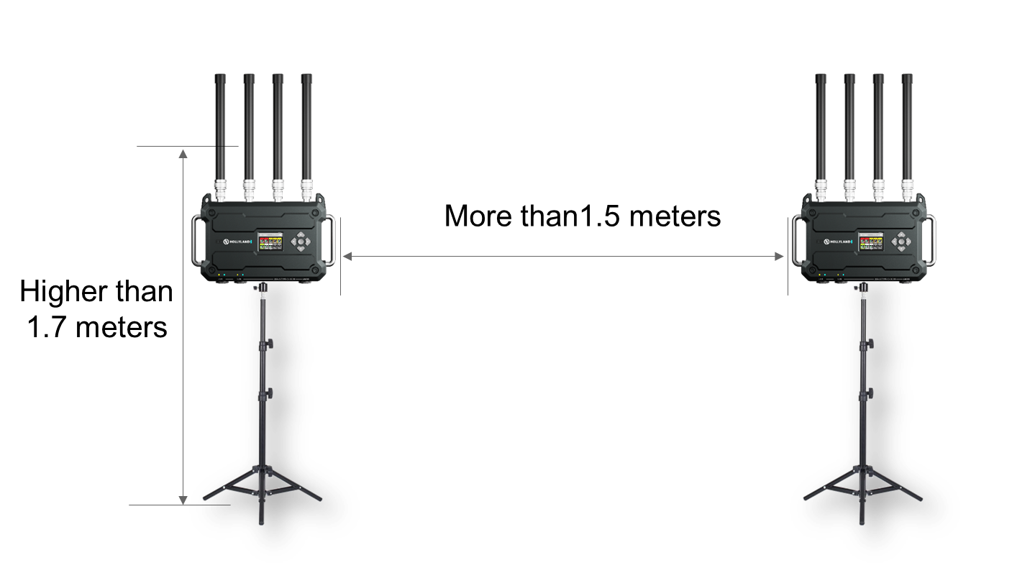

2. Cascade Settings
- Cascade Within Solidcom C1 Pro Roaming Hub Systems:
Cascade via the 4-Wire Interface:
- Connection:
Use a standard network cable to connect two hubs via the 4-wire interface. The length of the network cable is up to 300 meters.
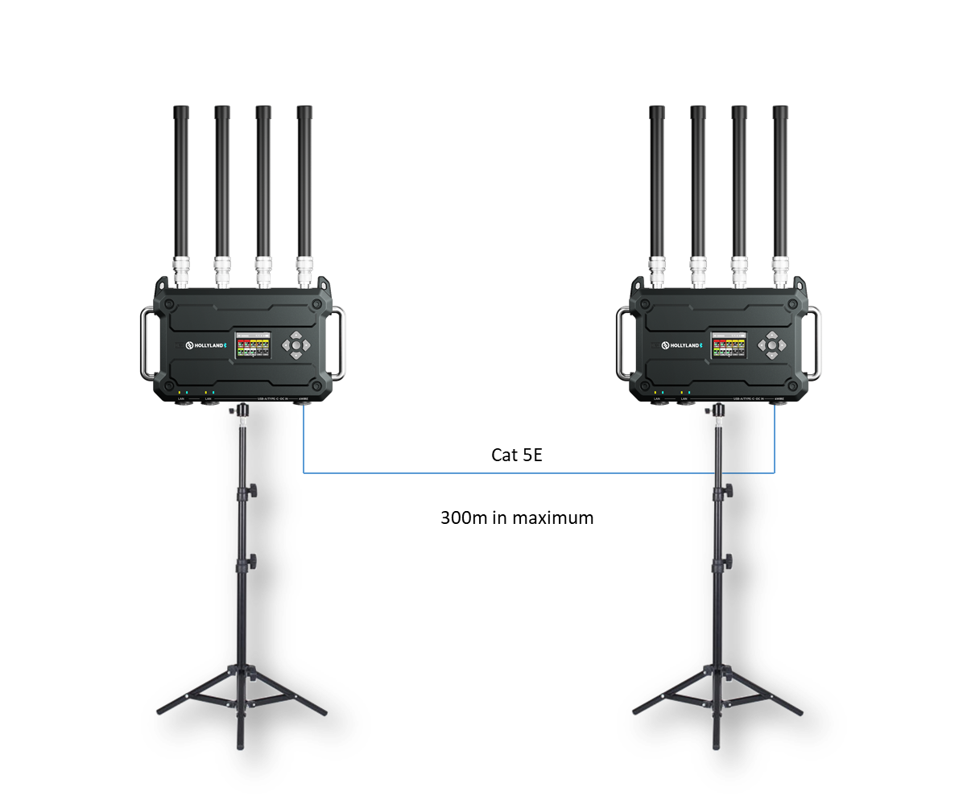
b) 4-Wire Settings:
After connecting two hubs using a network cable, select 4 Wire > Line Sequence Switching on the hubs, and then select Standard on one hub and Cross on the other hub.

Cascade via the RJ45 interface:
- Connection:
Note: Before connect the two hubs via RJ45 ports, please make sure all of the headsets and hubs turned on, and all of the headsets connected to the corresponding Hub already.
Use a standard network cable to connect two hubs via the RJ45 interface. Either of the two RJ45 interfaces on the hub works. The length of the network cable is up to 100 meters(Cat 5e) / 200 meters(Cat 6e).
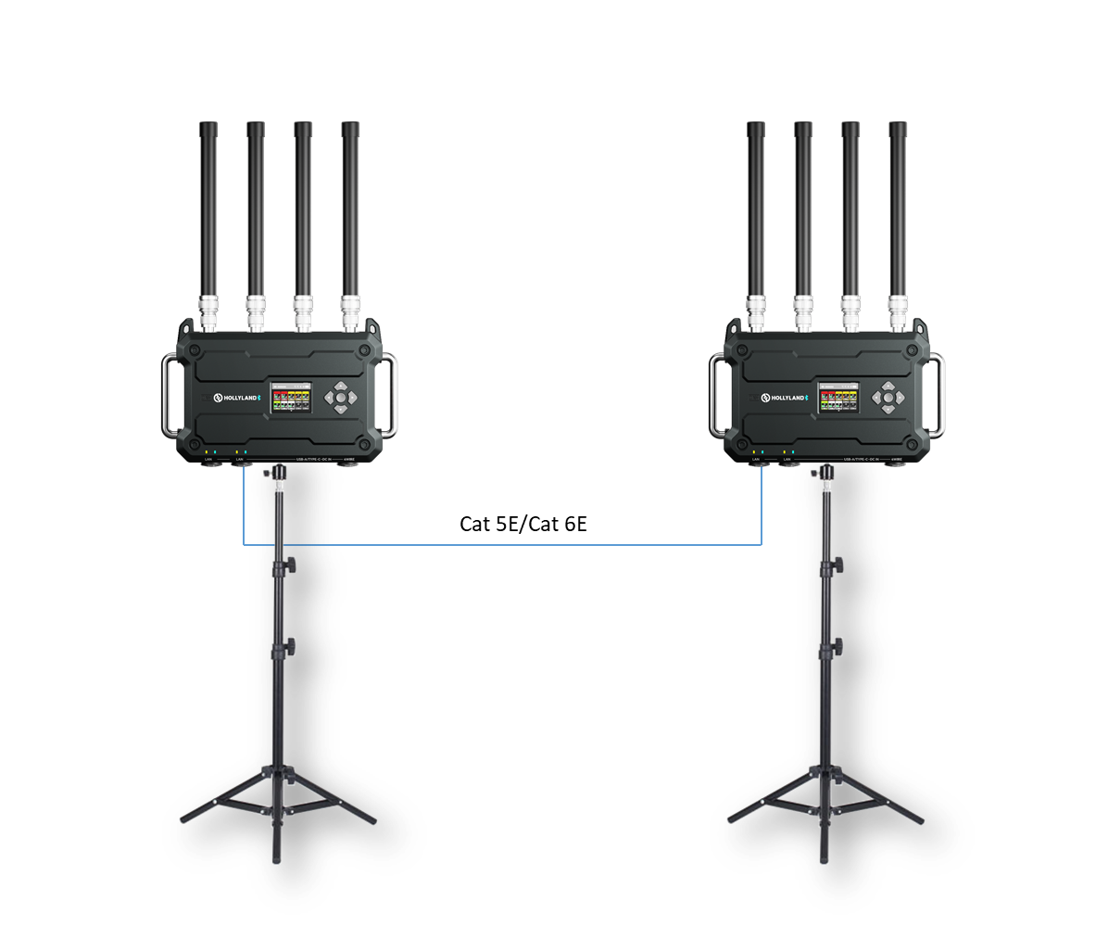
It does only support 2 hubs connection. On one hub, select Master Device, and on another hub, select Remote Device.

b) Settings:
After connecting two hubs using a network cable, select M & R on the hubs to set the hub mode. On one hub, select Master Device. On the other hub, select Remote Device > Scan and then select the IP address of the corresponding master hub.
Note: The function of obtaining the IP address automatically under Network > Wired Network Setting needs to be turned off on both two hubs.

Pre-Sales FAQs

1. How Many Groups Does Solidcom C1 Pro Roaming Hub Support?
The Solidcom C1 Pro Roaming Hub system supports 6 groups (Ch1 to Ch6), but with Solidcom C1 or C1 Pro headsets only support 2 groups, A & B buttons can be allocated to any 2 channels from 6.

2. What's the transmission range of the Hub？
It is 500 meters in omnidirectional.

3. How Many Remote Headsets Can Work with One Hub？
Up to 20 remote headsets

4. Can the Solidcom C1 and Solidcom C1 Pro headsets work with Solidcom C1 Pro Roaming Hub ?
Yes, it's compatible, just need to make sure all of them work with the latest firmware version.

5. How many sets of Solidcom C1 Pro Roaming Hub-HUB can be cascaded?
2 pcs in maximum with IP cascade mode，and 2 pcs with 4W cascade mode.

6. What does the roaming function means?
It means one headset can connect to two hubs, when the headset moving in the range of two hubs, the headset will switching connections between two hubs automatically according to the signal strength.

Operation FAQs

1. How to Manage Groups with the Solidcom C1 Pro Roaming Hub System?
The groups can be managed in browser based software or "Hollyvox" APP.
Browser based software:
Use a network cable to connect the hub to a computer via the RJ45 interface and set the IP address of the computer (make sure it is in the same LAN as the hub), open the browser, and then visit 192.168.218.10 (default value that can be modified) to enter the configuration page for the hub.
APP:
Open the "Hollyvox APP", and then add one device to connect to the base station via Bluetooth.

2. How to Use the UAC Function of the Solidcom C1 Pro Roaming Hub Hub?
Connect the hub to a computer using a USB-C to USB-A cable, and then the computer will recognize the hub as an audio device (one channel IN and one channel OUT).

3. Why the headset can not roaming to another Hub when cascade by IP?
- Please make sure both of the hubs set as Master and Remote
- When the IP cascading over the network switcher or fiber device, the Roaming function will doesn't work anymore.

